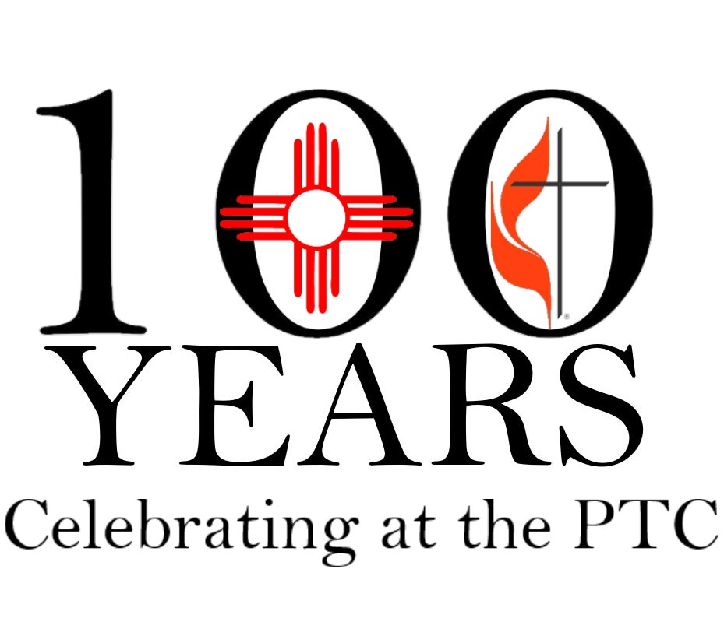
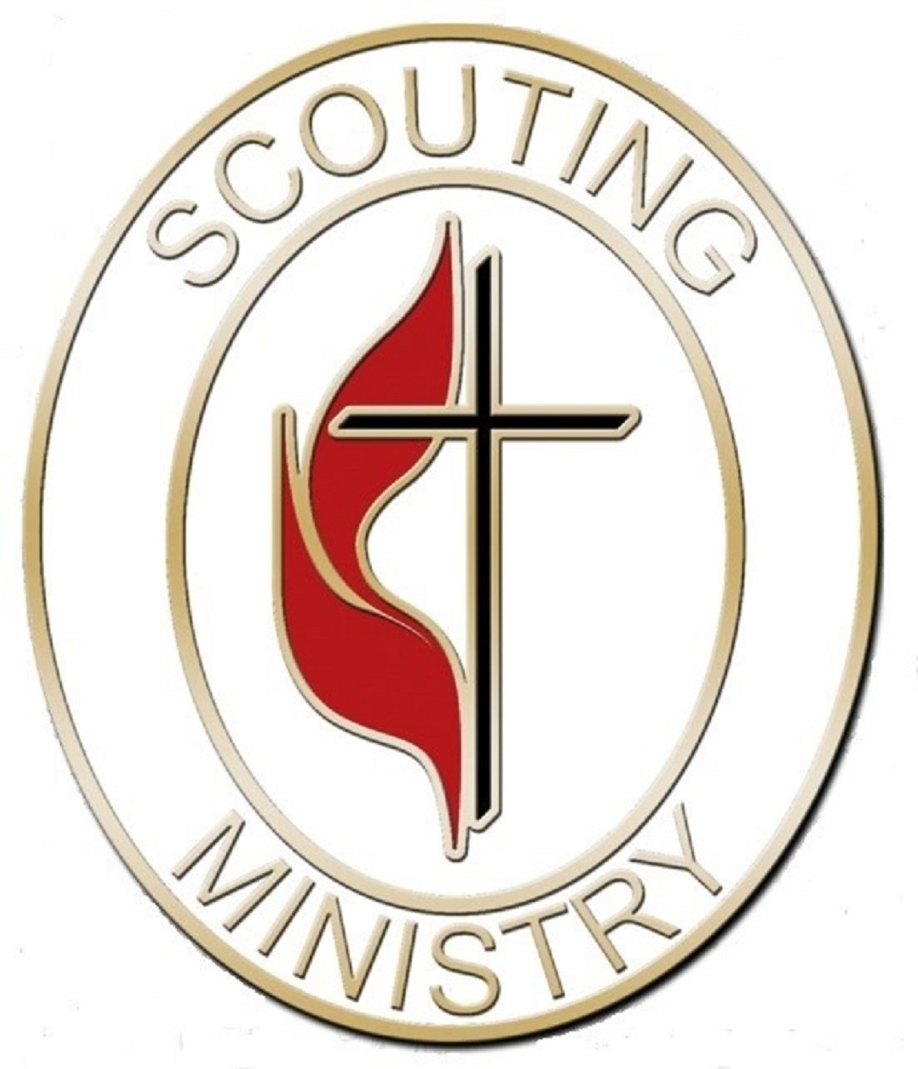
Virginia Conference Scouting Ministries
2020 Buford Road
North Chesterfield, VA 23235-3467

Scholarship Application for United Methodist Scouters Conference
At Philmont Training Center, June 11-17, 2021
Scholarship Sponsored by the Virginia Ministry of Scouting

APPLICATION DEADLINE APRIL 1, 2021
Applicant Information

Full Name: Date:
Last First M.I.

Address:
Street Address Apartment/Unit #

City State ZIP Code

Phone: Email

Church Information

Church: _______________________________________________

Address: Phone:

Pastor: Email:

Current and Previous Positions in Local Church, District, and/or Conference:

Current registrations: BSA GSUSA Big Brothers Big Sisters
Scouting Information

Current and Previous Positions in Scouting:

Years of registration / ministry: _______
References
Please list two references from leaders in church or scouting.

Full Name: Relationship:

Unit type #: Phone: Email:

Address:

Full Name: Relationship:

Unit type #: Phone: Email:

Address:

Calling

Why are you in Scouting?

Disclaimer and Signature

I certify that my answers are true and complete to the best of my knowledge.
Scholarships are a partial scholarship to strengthen the commitment of the participant. The scholarship is for $200 toward the total registration ($495). We require that the initial registration be completed before a scholarship check will be issued as a reimbursement. Conference Registration web address:
https://reservations.scouting.org/profile/form/index.cfm?PKformID=0x123501f9b1

Scholarships are based on available funds, need within the annual conference / jurisdiction, participation, and future willingness to engage in the ministry of scouting.

Signature: Date:

RETURN BY MAIL POSTMARK BY APRIL 1 OR RETURN BY EMAIL DATED BY APRIL 1

Virginia Conference Scouting Ministry BCUMCBSA@JUNO.COM
RE: Scholarship Application
2020 Buford Road
North Chesterfield, VA 23235-3467

